Fashion Survey Analysis

By: Jeffrey Robertson, Neel Chunara, Ruby Landry, and Shelly Sakkerwal

The area that we chose to cover in this project was the customer trends when buying clothing. We found a dataset that mimicked information from the United States and United Kingdom. The goal was to analyse the data and report any noticeable trends that could be found that businesses might use to be able to strategize and plan for future campaigns. Some of the questions that we sought to answer were if there was trends to why customers gave reviews, if there was any connection to the brand and their reactions on social media, when do different age groups do their shopping, or if there was any style or trend that was selling better than the others. Through our analysis we hoped to unearth and frame some helpful visuals to allow for smarter decision making

We did the analysis on Fashion Dataset and we analysed if the company should invest in after sales services like reviews, social media comments and feedback as these aspects play a crucial role in the decision making process of potential customers. Customer feedback assists potential buyers in making informed decisions by addressing concerns and providing additional information. Engaging with customer comments and feedback allows effective reputation management and can turn dissatisfied customers into loyal advocates.

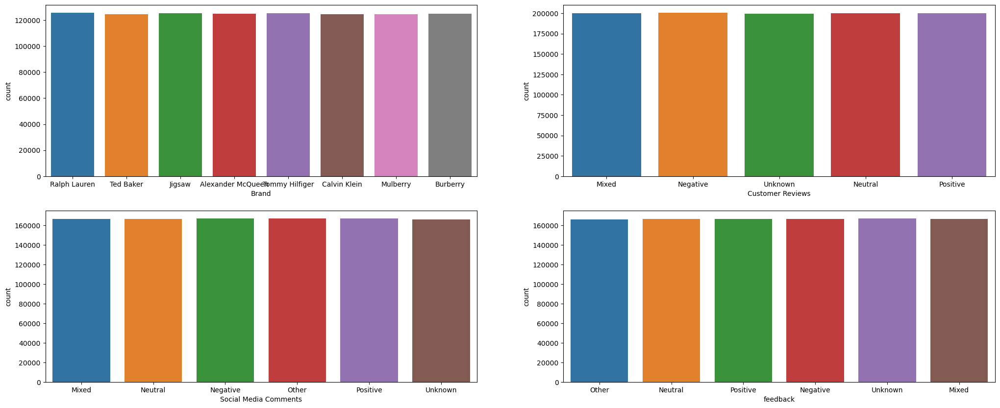

**Bar chart representing Brand vs Customer Reviews vs Social Media Comments vs Feedback**

Based on the analysis, almost all the brands have invested in their sales services because the values are similar. We also got to know that the number of products per brand are similar.

The other question we worked on was, does age impact how people are influenced by social media? The data analysis shows that the age doesn't affect the social media comments because the results are very similar.

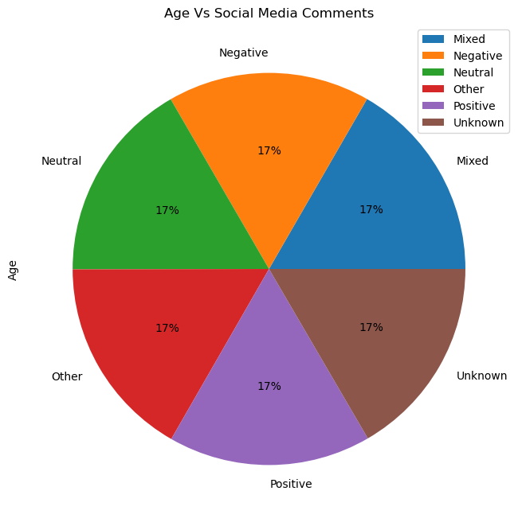

In an effort to gain a better understanding of consumer preference and purchasing behaviour, we wanted to analyse if there was any correlation for sizes purchased for specific styles or brands. Understanding the relationship between sizing popularity and specific brands or styles could assist companies to better understand their consumer, and allow them to tailor their marketing and sales strategies accordingly. If a given style was more popular for a specific size, this insight could help fashion companies optimise their marketing approach for specific styles.As well, it is important to understand the demands of the market to adjust supply accordingly. For brands it is useful for them to know which of their sizes are selling more frequently so that they can ensure adequate supply.

To start, we looked at various style attributes and the number of each size purchased by style. To do so, the data was first grouped by style attributes, including: ‘Streetwear', 'Vintage', 'Formal', 'Sporty', 'Edgy', 'Minimalist', 'Preppy', 'Glamorous', 'Casual', and 'Bohemian'. From there, the count of each size for each style attribute was summarised in a pivot table below.

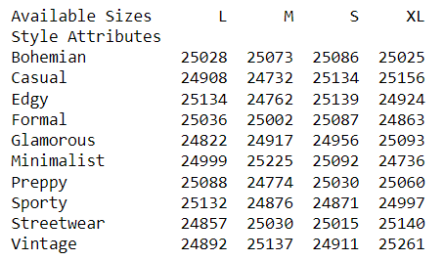

This data was then visualised in a bar chart shown in the figure below.

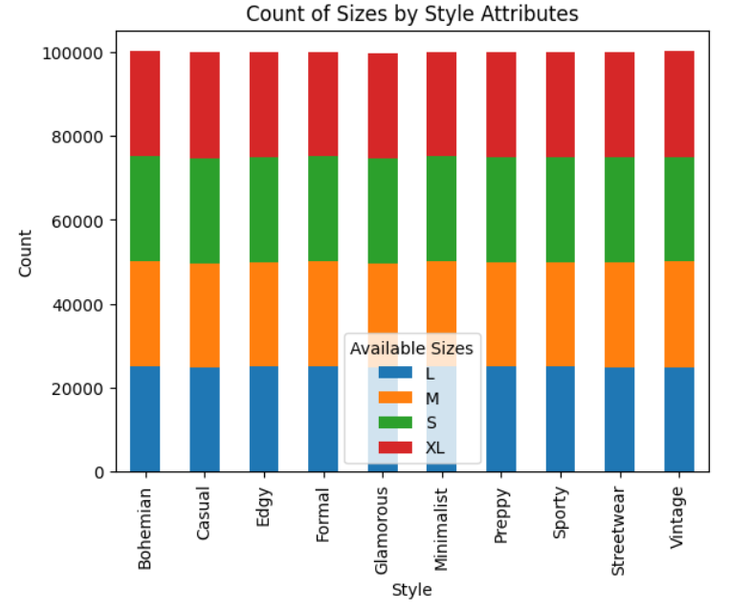

Overall, the difference in the number of specific sizes purchased both within brands and between brands was minimal, with all values falling into a range between 24732-25261. This indicates to us that based on this data set there are minimal trends in sizing popularity between various styles.

Similarly, we also wanted to analyse the relationship between size and specific brands. The data was again grouped by individual brands including 'Ralph Lauren', 'Ted Baker', 'Jigsaw', 'Alexander McQueen', 'Tommy Hilfiger', 'Calvin Klein', 'Mulberry', and 'Burberry'. The pivot table below summarises the counts of each size by brand. This data was used to create the bar chart below.

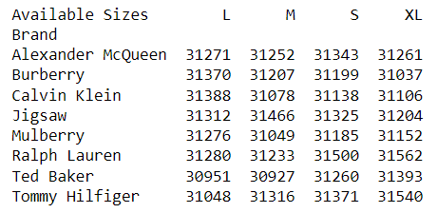

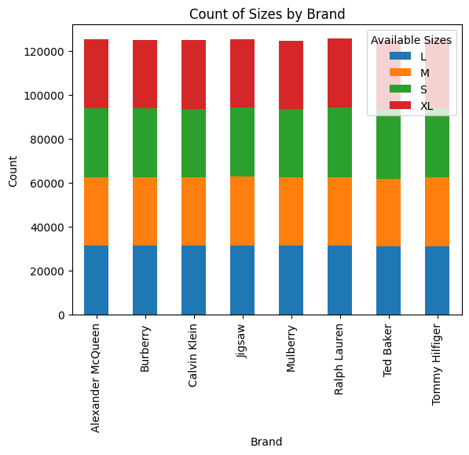

Similarly to style and size occurrence, the relationship between brand and size was minimal, with all values falling into a range between 30927-31562, indicating that there is minimal correlation between brand and sizes purchased. Overall, there was found to be no statistically significant trends for sizing popularity for both styles or brands.

Our team undertook an investigation into the seasonal trends within the fashion industry. Specifically, our focus is on identifying potential correlations between seasons and various style attributes, categories, colours, and brands. To accomplish this, we are working on a comprehensive dataset consisting of 67,600 unique product sales records, encompassing both sales data and sales process attributes.

Through our analysis of this dataset, our objective is to provide valuable insights to a company, enabling them to make informed decisions and incorporate these findings into their marketing strategy and forecasting. By analysing current trends, we aim to assist the company in optimising their marketing spend and capitalising on the existing market dynamics.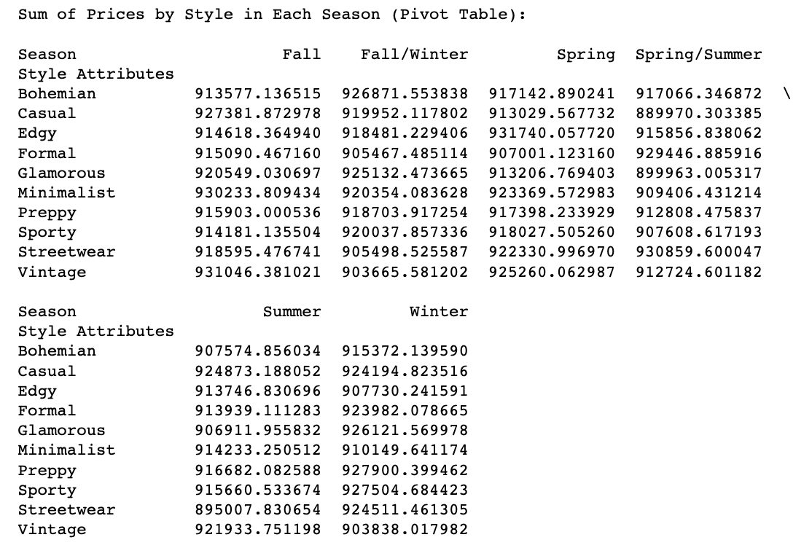

Our analysis focuses on identifying prevailing trends within the fashion industry based on the five distinct seasons: Fall/Winter, Spring, Spring/Summer, Summer, and Winter. In terms of sales performance, the Minimalist style stands out with the highest total sales amounting to $931,740.06 during the Spring season. On the other hand, the Streetwear style recorded the lowest sales of $895,007.83 during the Summer season.

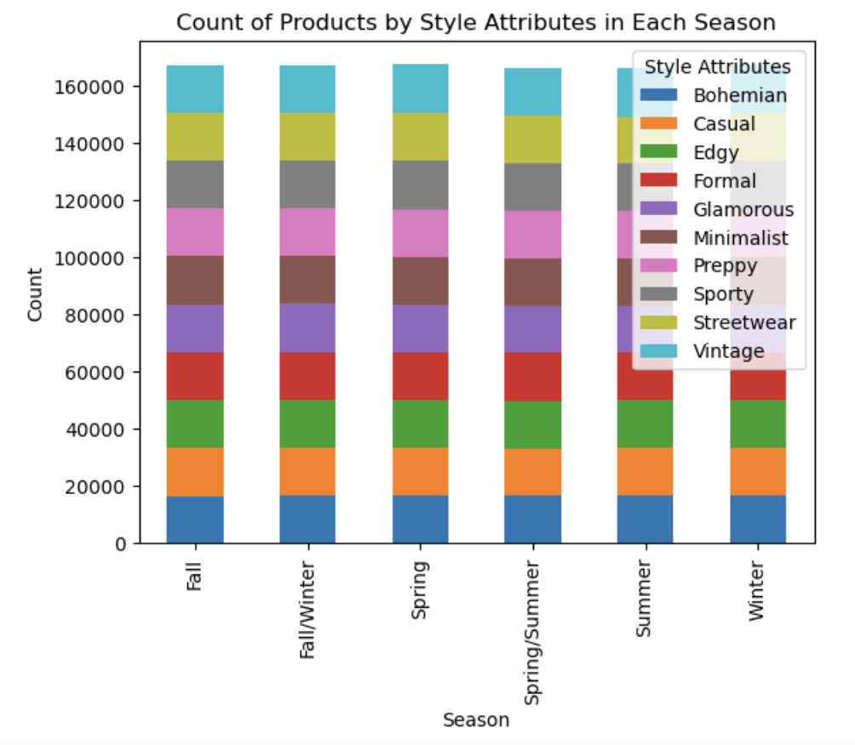

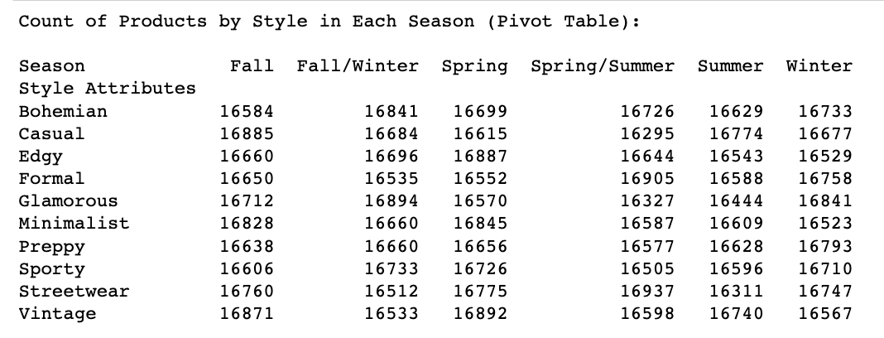

Additionally, based on the **volume of products sold,** the **S**porty and Streetwear styles take the lead in the Spring/Summer season, with both styles having 16,937 units sold. On the contrary, the Sporty style registers the lowest number of products sold during the Spring season, with a count of 16,506 units.

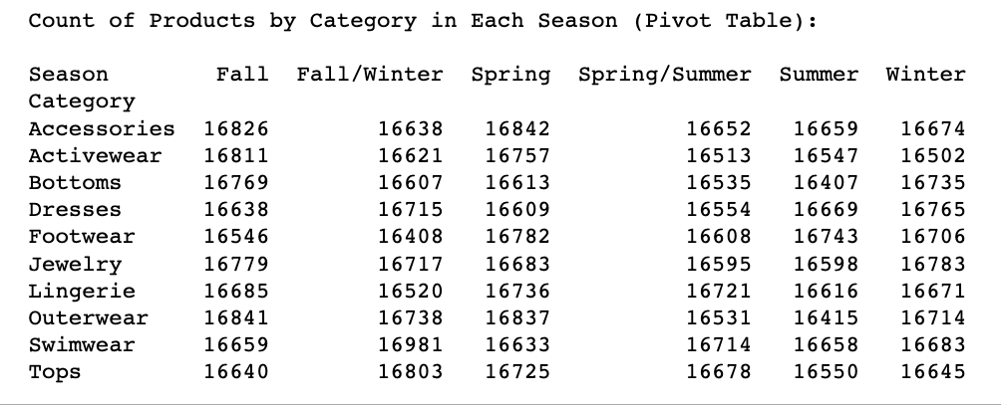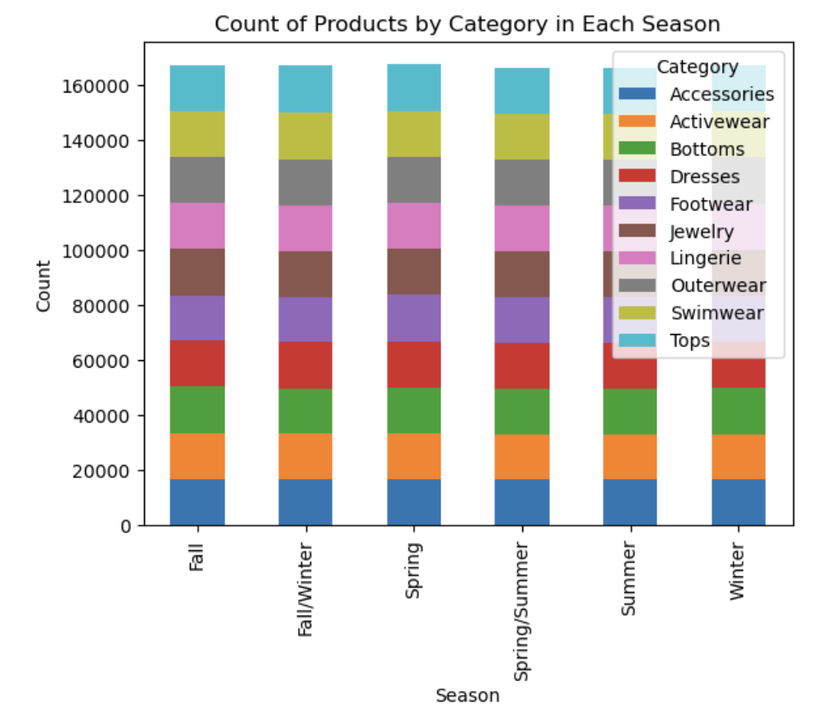

**Seasonal trend based on the product category**: The Accessories category sees the highest product count in Spring (16,842), while Winter has the lowest count (16,674).However, Fall/Winter has the highest count of products in several categories, including Dresses, Outerwear, and Swimwear, indicating a preference for these items during the colder seasons.

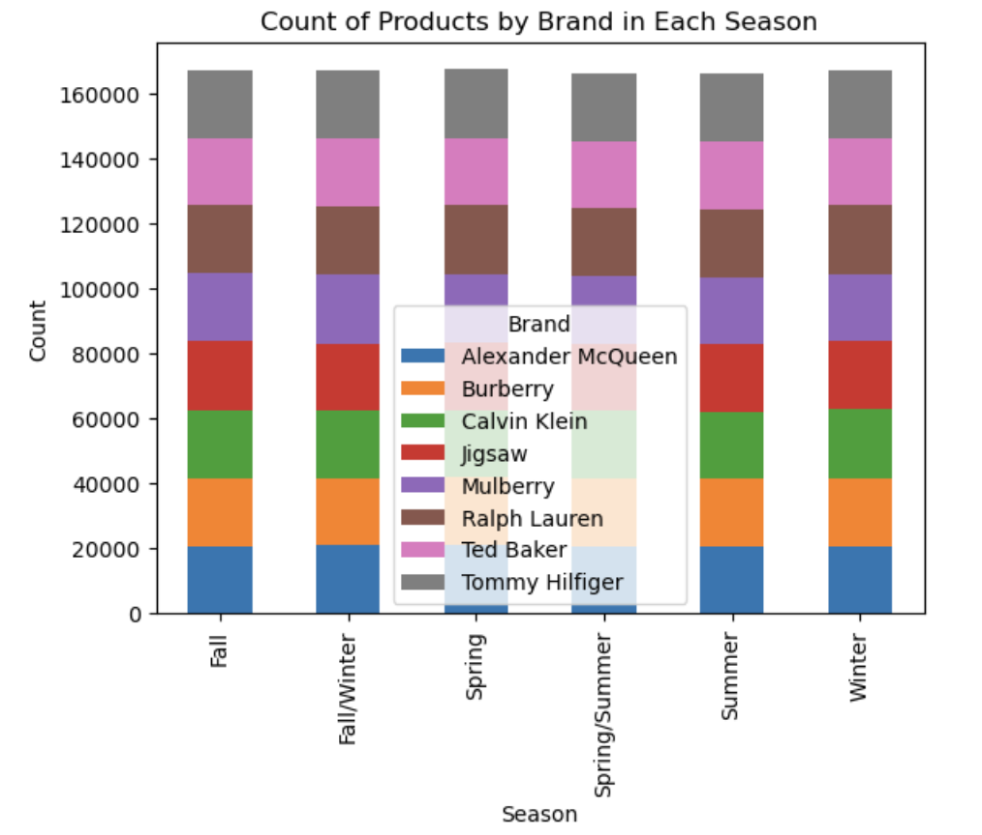

**Seasonal trend based on the product brand:** Burberry consistently maintains a high count of products across all seasons, while Calvin Klein experiences a slight variation with lower counts in Summer (20,570) and higher counts in Winter (21,222)

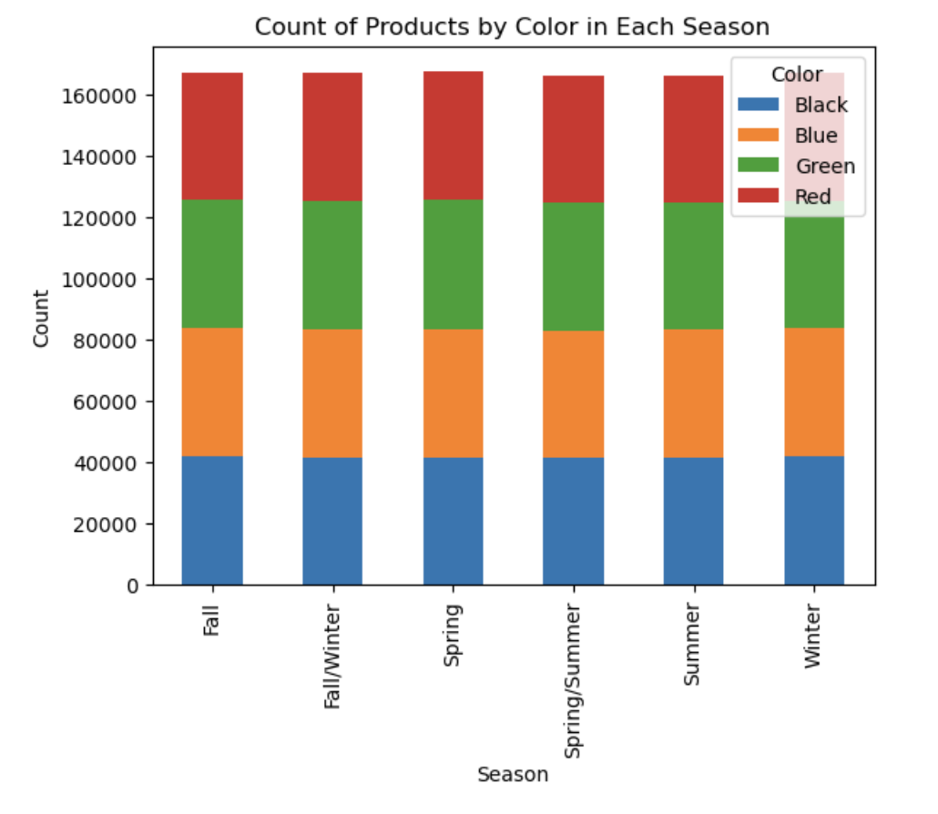

**Seasonal trend based on the Color**: Across all seasons, Black consistently has the highest count of products (ranging from 41,368 to 41,968), while Green shows slight variation with the highest count in Spring (41,955) and the lowest count in Summer (41,266).

By thoroughly examining these sales and product metrics across different seasons, we can gain valuable insights into the dynamics and preferences within the fashion industry.

One of the questions we had was what time-period shoppers of a specific age did their shopping. The data set provided 5 different time periods: evening, daytime, weekend, nighttime, and holiday. From there, there was a need to group it was decided to group the ages to six groups based on the lowest age to the highest age of the data set. The first group, age 18 to 26, had a slight favour for shopping in the evening or on a holiday with both categories holding 20.2% each. Age 25 to 34 did most of their shopping during the weekend, with 20.2% done during that period.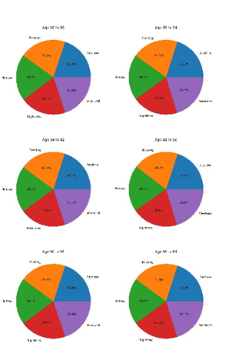

The rest of the age groups held a similar pattern with no category really having a more favourable time-period. There was no significant statistical difference between the categories to be able to determine that there is a time-period that specific ages prefer to shop in according to the date provided.

One of the ways to bring in sales of clothes is to bring in a recognizable face to market the product. A question being asked is if a certain influencer would impact the age of

the shopper purchasing the product. To evaluate this, the average age of the customer was compared to the fashion influencer to see if there was a statistically significant difference in the age of customer based on the fashion influencer. Based on the data it does not appear that a customer is not statistically significant when it comes to purchasing the item. The distribution of ages was similar for each age group. The data shows that the fashion influencers did not hold a large bearing or pull of a single age group. This could mean that each influencer has a wide-spread appeal or that the influencer does not hold a large sway on whether the customer will purchase the product.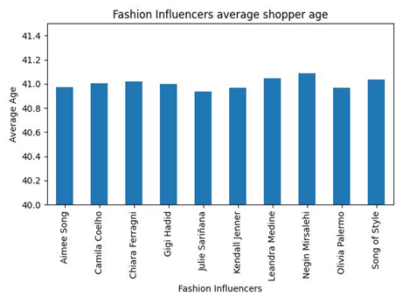

One of the factors that was looked at was the value of products compared to their rating and whether the price would affect the rating of a product. The chart of “Rating v Prices” maps out a random sample of 10,000 items from the dataset used. The data shows the price and rating in the chart is spread out evenly throughout the sample taken. The average price from the sample price is $54.50. When compared to the overall mean of the population is $55.00 meaning that the data is not too far off from the population. The rating and price are both equally distributed and there is not a high likelihood that the Price affects the rating of the product based on the wide variety of prices and ratings.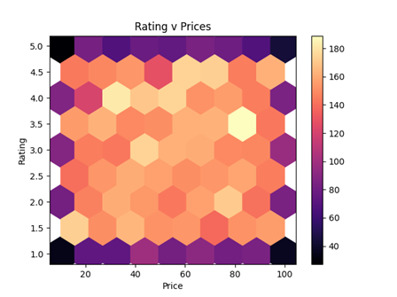

When the prices were grouped together, the data shows that there was not much difference in the rating with the lowest being 2.9953 and the highest average rating being 3.0005. To be able to say that the higher prices would lead to lower reviews, the data would be expected to show a negative correlation between the price of an article of clothing and the rating that the user provided. It is more likely that there is no correlation in this dataset between either of the values.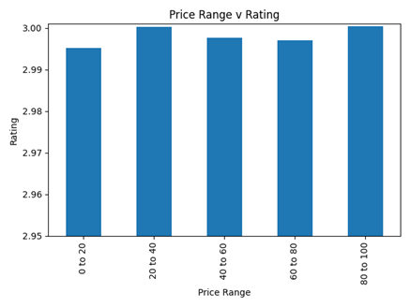

Overall, our analysis aimed to uncover correlations that may exist in fashion trends and in purchasing behaviour of the consumer. By looking at customer reviews, social media comments, and purchase history we were looking to assess if consumer interaction after a sale influences future sales and affects purchasing behaviour.To understand seasonal sales trends for specific styles, colours, product type and brands which we did by assessing the number of products purchased and total sales in each category. To understand the purchasing behaviour of consumers, we looked at the time periods consumers shopped based on their age, as well as the relationship between customer age and influencer. Overall, our analysis of the data revealed minimal correlations or trends in the various aspects of the fashion industry that we examined. One of the main limitations of our dataset was that it likely does not reflect realistic data in fashion or purchasing trends as all data analysed was very evenly spread in every category.